ST. THOMAS AQUINAS
Lunch Menu
Gluten Free & Special Diets are Available: Speak with the Dining Manager

Week of September 30 – October 4, 2024

Food Service Office: Sean Gannon

Telephone Number: 603-609-1450
Morning  Editions | MONDAY  Presently Unavailable | TUESDAY  Presently Unavailable | WEDNESDAY  Presently Unavailable | THURSDAY  Presently Unavailable | FRIDAY  Presently Unavailable
 | Pizza  Cheese  Pepperoni | Pizza  Cheese  Pepperoni | Pizza  Cheese  Meatlover | Pizza  Cheese  Buffalo Chicken | Pizza  Cheese  Pepperoni
crEATe | Buffalo Chicken Wraps  Chicken Caesar Wraps | Breakfast 4 Lunch  Eggo Waffles or French Toast  w/Syrup  Potato Puffs  Breakfast Sausage | Tortellini  w/Alfredo or Marinara Sauce  Chicken Parmesan  Broccoli  Garlic Bread | Taco w/ Nachos  Tortilla Chips  Beef Taco Meat  Shredded Lettuce  Diced Tomato Shredded Cheese  Salsa/Sour Cream | Popcorn Chicken  Mashed Potato w/Gravy  Vegetable
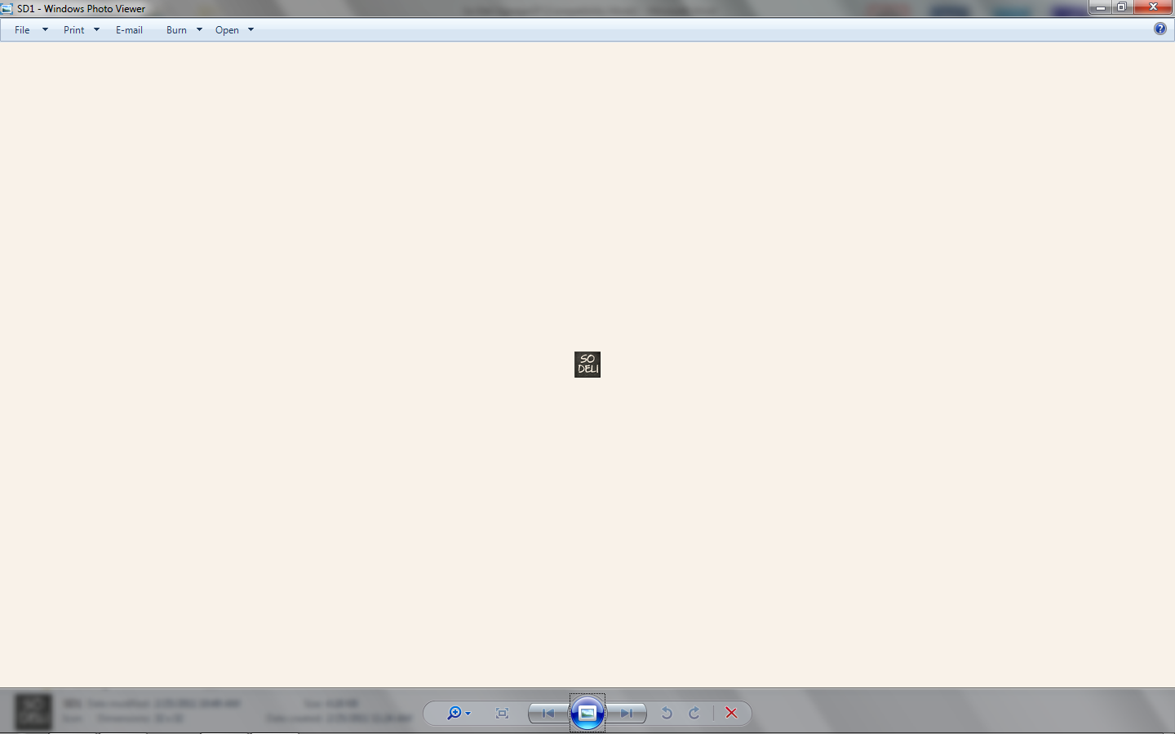 | The Wrap Station is Closed Today | The Wrap Station is Closed Today | Deli Wraps and Sandwiches  Made to Order | Deli Wraps and Sandwiches  Made to Order | Deli Wraps and Sandwiches  Made to Order
 | Variety of packaged Salads, Yogurt Parfait, Fruit Cups | Variety of packaged Salads, Yogurt Parfait, Fruit Cups | Variety of packaged Salads, Yogurt Parfait, Fruit Cups | Variety of packaged Salads, Yogurt Parfait, Fruit Cups | Variety of packaged Salads, Yogurt Parfait, Fruit Cups
grilled  EXPRESS | Variety of Burgers  Chicken Pattie  French Fries | Variety of Burgers  Chicken Pattie  French Fries | Variety of Burgers  Chicken Pattie  French Fries | Variety of Burgers  Chicken Pattie  French Fries | Variety of Burgers  Chicken Pattie  French Fries
* Menus subject to change

